TOPIC 5 : GREEDY
1.
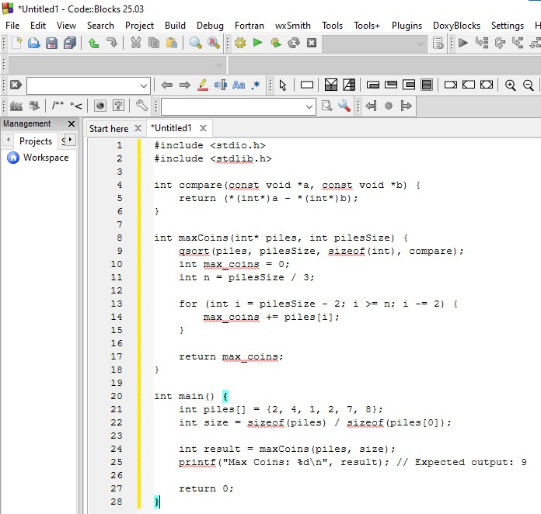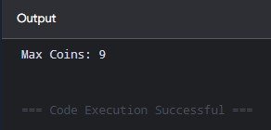
Time Complexity: $O\left(k\log{k}\right)$ where $k$ is the number of elements in piles.
Space Complexity: $O\left(1\right)$

2.
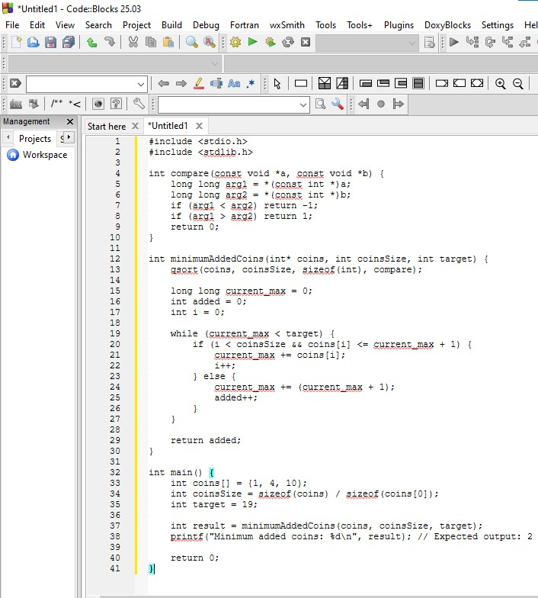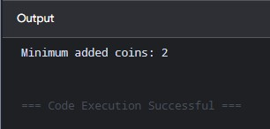
Time Complexity: $O\left(n\log{n}+\log\left(\text{target}\right)\right)$ where $n$ is the number of elements in coins
Space Complexity: $O\left(1\right)$

3.
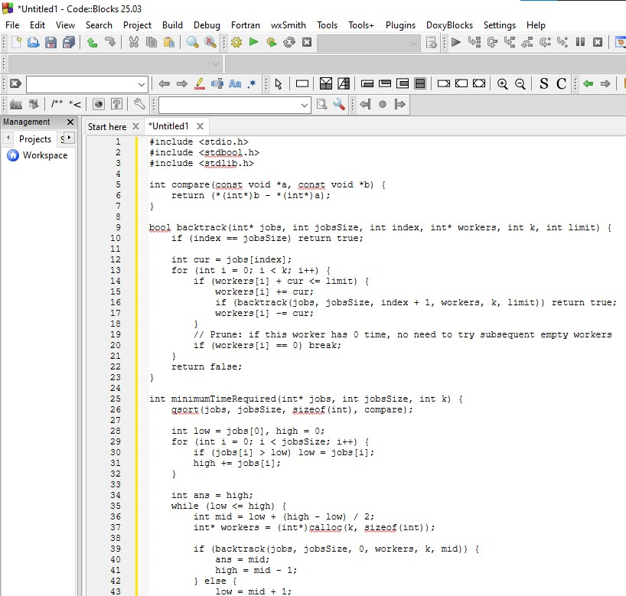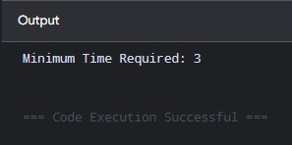
Time Complexity: $O\left(k^{n}⋅\log\left(\sum{\text{jobs}}\right)\right)$ worst-case search pruned bound (where $n$ is the number of jobs)
Space Complexity: $O\left(n+k\right)$

4.
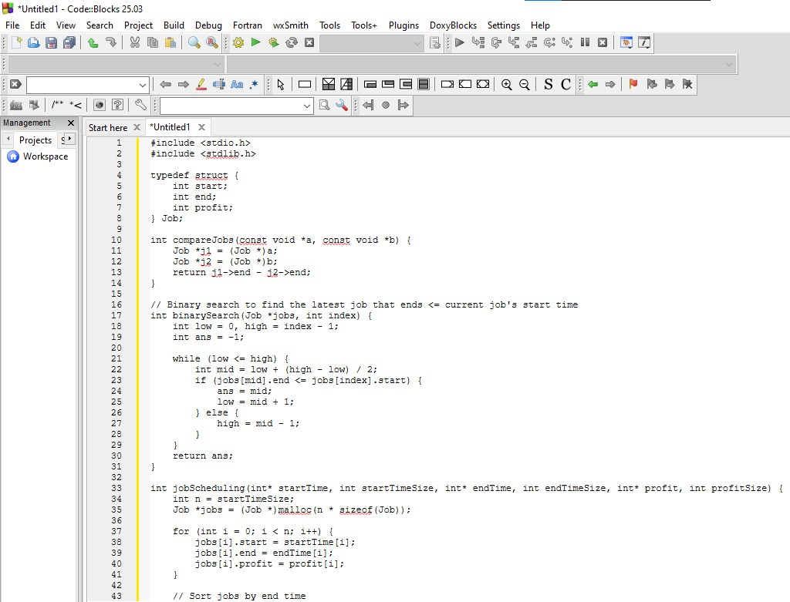
Output:
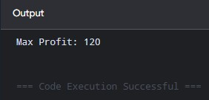
Time Complexity: $O\left(n\log{n}\right)$ where $n$ is the number of jobs
Space Complexity: $O\left(n\right)$

5.
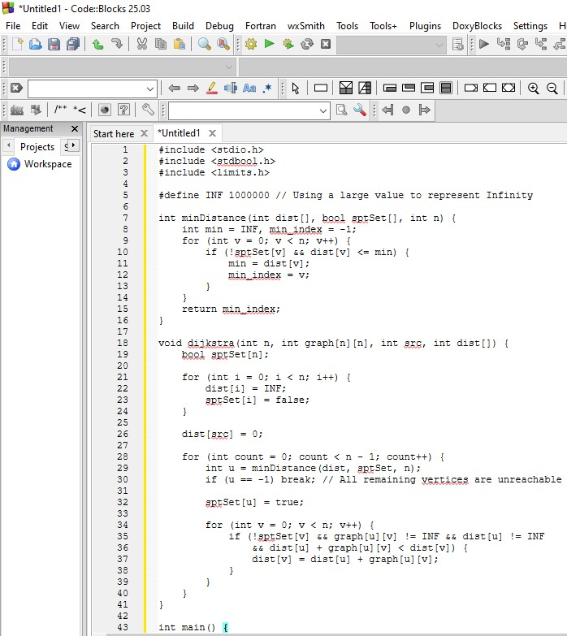
Output:
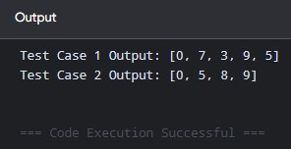

Time Complexity: $O\left(V^{2}\right)$ where $V$ is the number of vertices $n$
Space Complexity: $O\left(V\right)$

6.
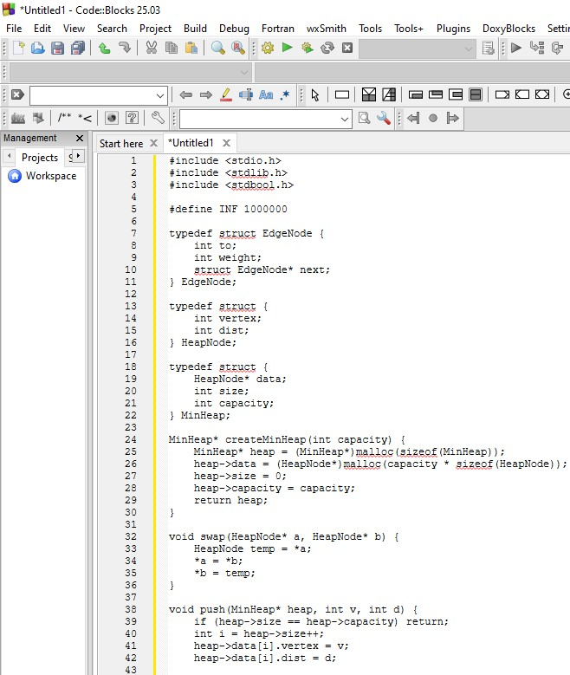
Output:
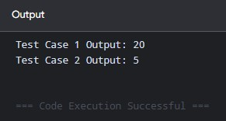
Time Complexity: $O\left(\left(V+E\right)\log{V}\right)$ where $V$ is vertices $n$ and $E$ is total edges
Space Complexity: $O\left(V+E\right)$

7.
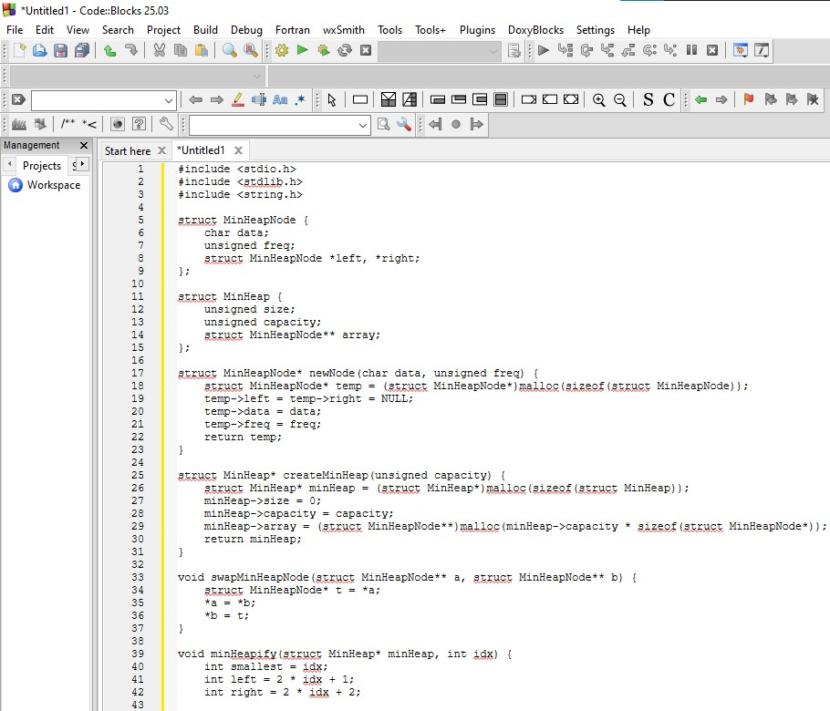
Output:
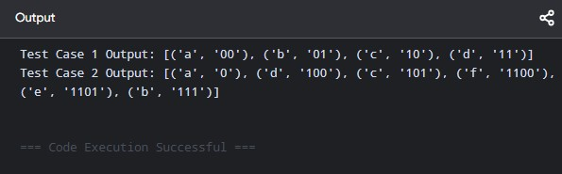
Time Complexity: $O\left(n\log{n}\right)$ where $n$ is the number of characters
Space Complexity: $O\left(n\right)$

8.
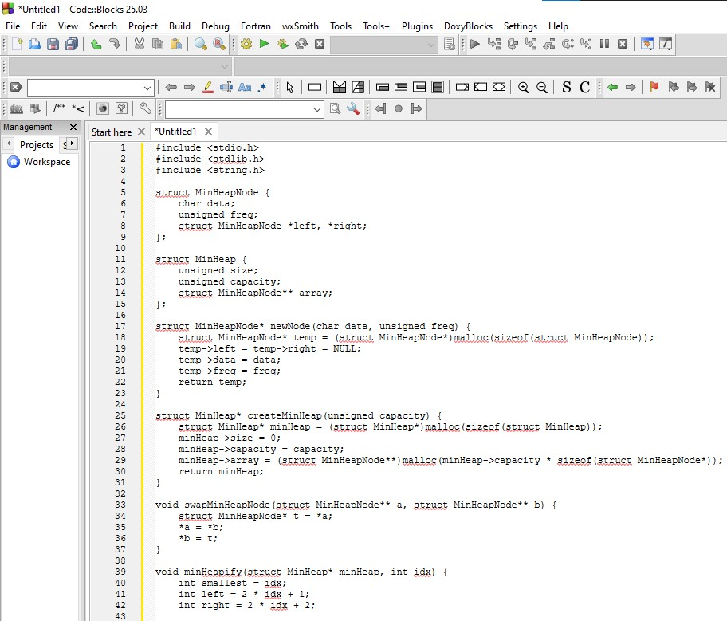
Output:
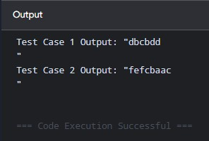
Time Complexity: $O\left(n\log{n}+m\right)$ where $n$ is the number of distinct characters and $m$ is the length of the encoded string
Space Complexity: $O\left(n\right)$
9.
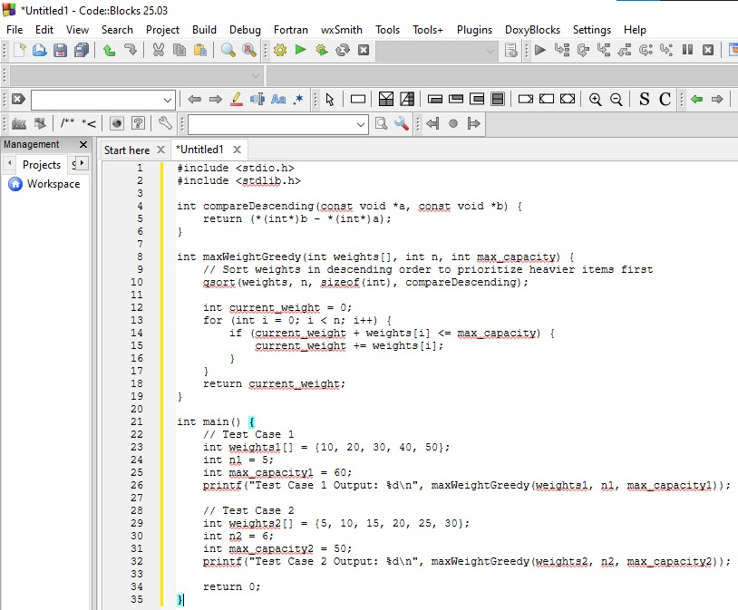
Output:
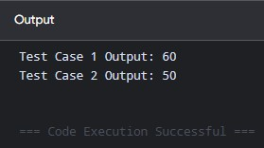
Time Complexity: $O\left(n\log{n}\right)$ where $n$ is the number of items (due to sorting)
Space Complexity: $O\left(1\right)$

10.
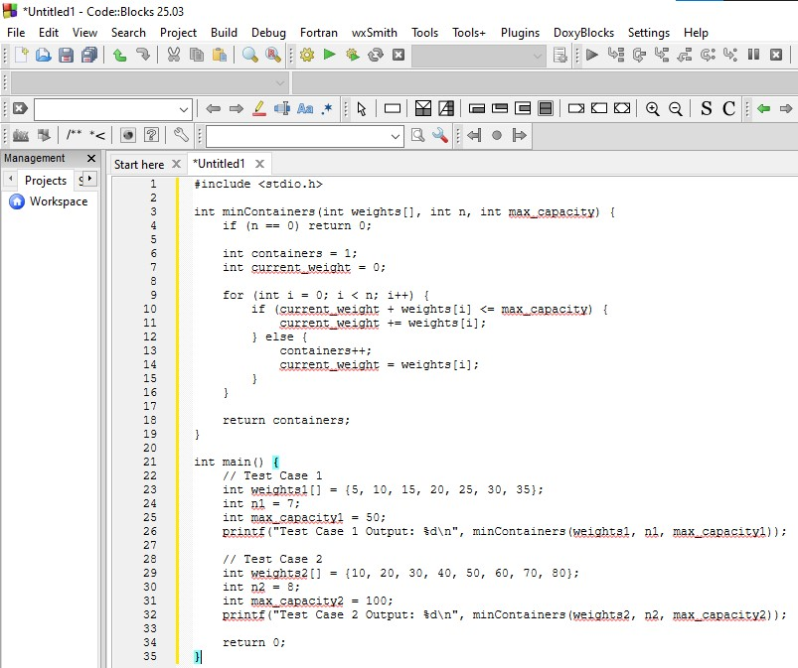
Output:
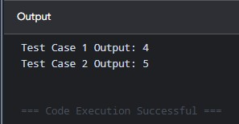
Time Complexity: $O\left(n\right)$ where $n$ is the number of items
Space Complexity: $O\left(1\right)$

11.
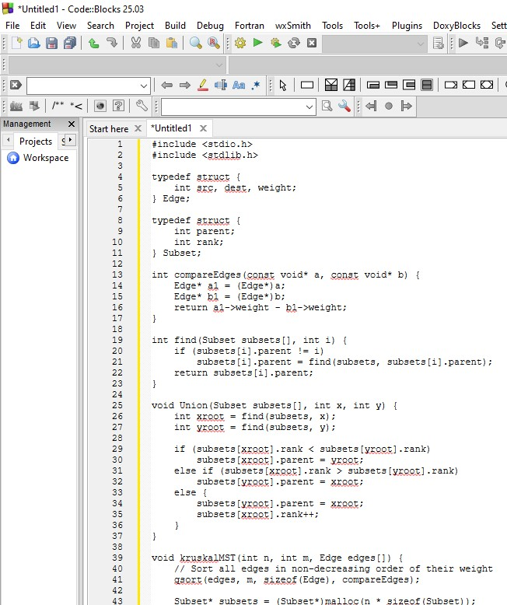
Output:
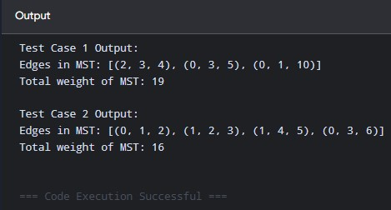
Time Complexity: $O\left(m\log{m}\right)$ where $m$ is the number of edges
Space Complexity: $O\left(n+m\right)$

12.
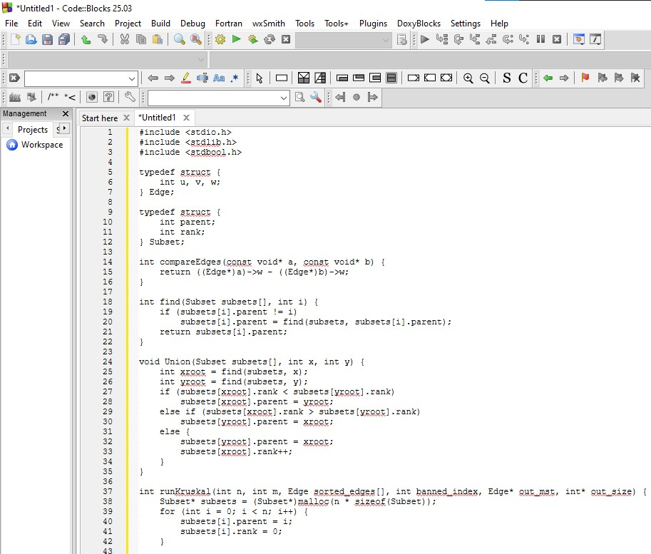
Output:
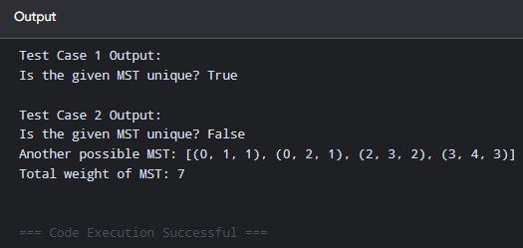
Time Complexity: $O\left(m⋅\left(m\log{m}\right)\right)$ where $m$ is the total number of edges
Space Complexity: $O\left(n+m\right)$

